**Web Design and Development Foundations with HTML5**

**Hands-On Practice (HOP)**

HOP 8.1

HOP 8.2

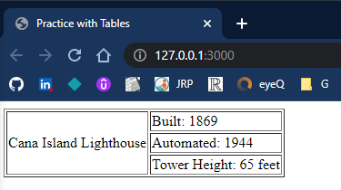

HOP 8.3

HOP 8.4